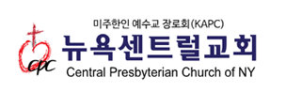

**2017 목장 월간 보고서 (Cell Church Monthly Report)**

____월(Month) 목장(Cell Church) :

목자/목녀 (Leaders):

|  |
| --- |
| 1. **목장모임 (Cell Meeting)** |
| |  |  |  | | --- | --- | --- | | 일시 (Date) | 장소 (Place) | 참여인원 (The number of Attendee(s)) | |  |  |  | |  |  |  | |
| 1. **기도제목 (Prayer Requests)** |
|  |
| 1. **건의사항 (Recommendations)** |
|  |

* **공지사항 (Notice)**

1. 주중 한번 이상 목원들에게 연락하여 근황을 물어주세요.

Please contact members in your cell more than once during the week.

1. 매일 목원들을 생각하며 기도해주세요.

Please pray for members in your cell every day

1. 매월 첫 주 금요일 (8시) 목자/목녀 기도회에 참석해주세요.

Please attend the prayer meeting for the cell church at the first Friday of every month at 8PM